Tri-State Marina Wetland Creation

*Tri-State Marina, Chesapeake, MD*

Conversion of Tri-State Marine area lot to 60,625 square foot wetland capable of managing and retaining stormwater.

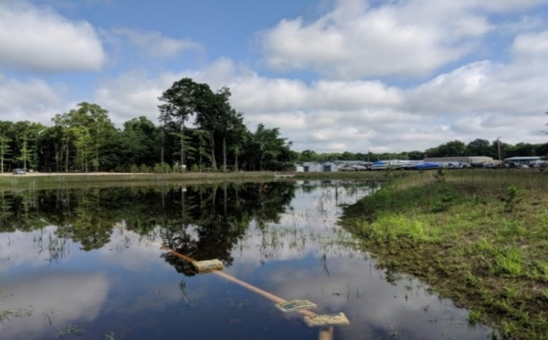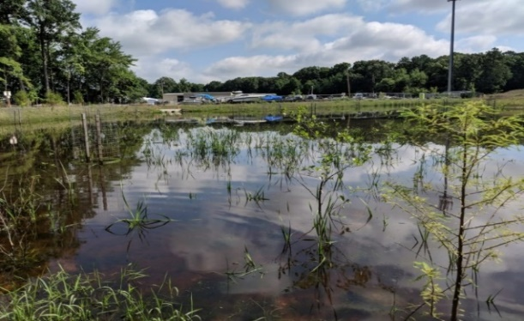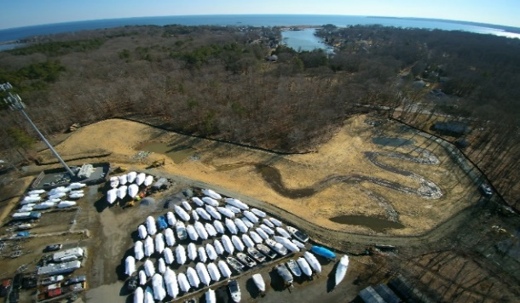

T

riangle Contracting, LLC teamed with Meadville Land Services on the Tri-State Marine Wetland Creation project in Anne Arundel County, MD. The area was originally a gravel lot used for storage of boats and trailers. The project converted this lot to a 60,625 square foot wetland capable of safely retaining 307,344 cubic feet of stormwater. The created wetland treats stormwater from two ephemeral drainage ditches that collect runoff from the surrounding Tri-State business park.

The project features two forebays to trap sediment and both high and low marsh areas for enhanced habitat diversity.

As a result of the constructed wetland, water flowing through the wetland works its way into a pool before slowly feeding through a concrete headwall and into Parker Creek. Additionally, the project consisted of planting 500 wetland trees and plants that contribute to the creation of a diverse and functional habitat in the wetland system.

